**Job Offer for a PhD Position**

1. **years – full time)**

The **CLIMEDUC consortium** is recruiting **5 PhD candidates** for the project:  
***"Climate Change Education Under Scrutiny: Towards a Theory of Institutional, Socio-Material and Cognitive Change through Education"***

The CLIMEDUC consortium is a dynamic and multidisciplinary research team (philosophy, education, sociology, and cognitive psychology) with recognized expertise and an international research network.

In total, **five PhD theses** will begin on **October 1, 2025**, within CLIMEDUC, funded by a **Concerted Research Action (ARC)** grant from **UCLouvain**. The project aims to develop a university pole of excellence in fundamental research in the field of **climate change education**.

This **PhD position (PhD 2)** focuses on the following issue :*“Climate Change Education Devices : mapping, typologisation and analysis of local translations »* (Axis 2 of the CLIMEDUC project; see project details on page 2).

**Offer :**

• One full-time, 4-year PhD position funded by **UCLouvain**;

• You will join the **CLIMEDUC** consortium;

• Supervision and training provided by **Prof. Marie Verhoeven** (Faculty ESPO, Sociology, GIRSEF) and **Prof. Miguel Souto Lops** (Faculty ESPO, Sociology, AGES/GIRSEF);

• A research path leading to a **PhD in Sociology after 4 years**, with the opportunity to complete the **doctoral training program** at **UCLouvain** as PhD student in Social and Political Sciences.You will also join the **EDTSS doctoral training program** (Thematic Doctoral School in Social Sciences, Wallonia-Brussels);

• The opportunity to obtain the highest academic degree (Doctor of Social and Political Sciences) at **UCLouvain**, ranked among the world’s top 200 universities.

**Desired Profile:**

• You hold a **Master of Science (120 credits)** in **Sociology or Social sciences (or equivalent)**; (a specialization or “option” in education and/or climate or environmental transition could be a “plus”);

• You are passionate about **social change** related to **climate change and environmental transition**, especially **through educational devices and practices ;**

• You are ready to commit full-time to scientific research for 4 years and are **highly motivated to obtain a PhD**;

• You have abilities to carry out empirical research in diverse fields (schools, associations…);

• You have a solid training or experience of **research methods in sociology** – especially **qualitative** approaches and **ethnography**;

• You feel enthusiastic about collaborating into a **collective** **research team** ;

• You are fluent in **French** and have a good command of **English**

**How to Apply?** Please send the following documents by email to **Prof. M. Verhoeven** (marie.verhoeven@uclouvain.be) and **Prof. Souto Lopez** (miguel.souto@uclouvain.be) **before June 23, 2025:**

* A **cover letter**;
* Your **CV**, including a transcript of academic results (combined in one file of max 10 MB).
* A sample of your research work (for eg. Your Master Thesis or any other relevant publication)

**Calendar and selection procedure**

After an initial selection, shortlisted candidates will be invited for a **final interview** at **UCLouvain – Louvain-la-Neuve**. An online interview is possible if needed.

* Selected candidates for interview will be notified on **June 27, 2025**.
* Interviews will take place on **July 3 and 4, 2025**.

**Overview of the project “CLIMEDUC”**

**Full title:**

Climate Change Education” Under Scrutiny: Towards a Theory of Institutional, Socio-Material and Cognitive Change through Education

**Main goal of the project:**

The CLIMEDUC project aims to contribute to delineate what can realistically be expected from education when it comes to address climate change, building on an empirical analysis of educational processes at different levels, their limitations and potentialities for generating change. By combining philosophy, education, sociology and cognitive psychology, CLIMEDUC aims to unravel the interplay between individual actions, social structures, and cognitive processes, to unravel the complex and interdependent mechanisms of change, and to develop a theory of institutional, socio-material, and cognitive change through education. The CLIMEDUC project is divided into 5 complementary and interrelated research axes, each of which corresponds to specific objectives and will lead to 5 doctoral theses.

**Project PI and co-PI:**

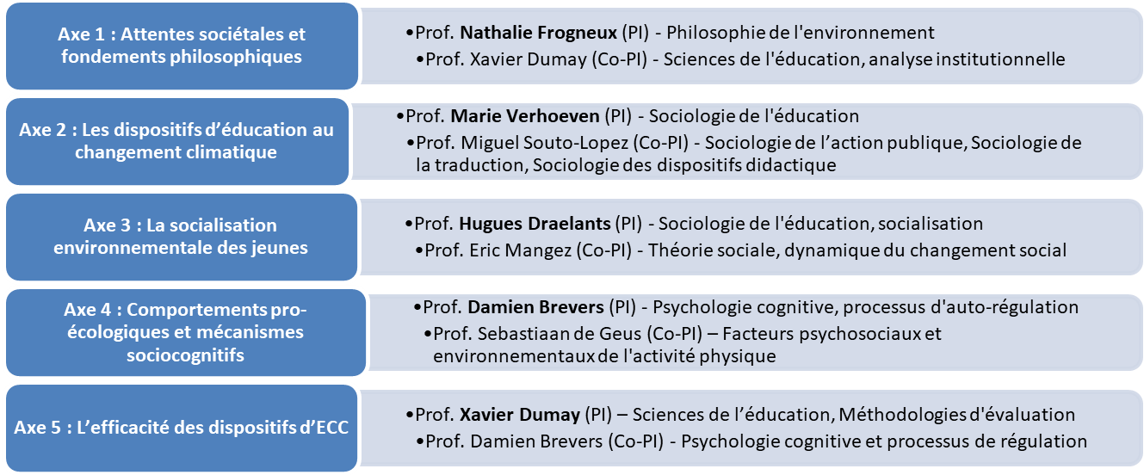

**Outline of axis 2 of the project “CLIMEDUC”**

***Climate Change Education Devices: Mapping, Typology and Local Translations***

The second axis of the CLIMEDUC project will concentrate on concrete CCE devices currently existing in the Wallonia-Brussels Federation. The project will pursue a threefold objective of *mapping*, *typologizing* and *analysing* the social logics underpinning the genesis, construction and implementation of such devices within situated educational spaces.

The doctoral student will develop an analytical framework crossing conceptual tools from the sociology of translation (Callon, Latour), the sociology of instruments of public action and the sociology of education. The aim of this study is to unravel the narratives and 'problematisations' of the issue of climate change that are conveyed and embodied by these devices (the assumption being that the there is a “loose coupling” between political narratives and devices). This will allow for a comprehensive understanding of these devices as instruments of innovation or transformation, embodying specific, situated representations of climate change and the role of education regarding this issue.

**Methodological design**. The thesis will be organised into three stages/studies: the first study, exploratory and descriptive, will aim to set up an inventory of the numerous and heterogenous existing CCE devices, within and on the periphery of educational institutions. The second phase will aim to build a typology of CCE devices according to (i) the narratives or conceptions they embody, (ii) their degree of proximity/distance/innovation to the school form (or classical “grammar of schooling”). A third study will select a small number of CCE devices that illustrate the typology and carry out an in-depth ethnographic study of them, with a view to gaining a detailed understanding of the processes involved in their development, choice and practical implementation, within contrasting educational contexts.