**, Image**

**Offre d'emploi pour un doctorat**

1. **ans - temps plein)**

Le consortium **CLIMEDUC** recrute 5 doctorant.e.s sur le projet**:**

***“Climate Change Education Under Scrutiny: Towards a Theory of Institutional, Socio-Material and Cognitive Change through Education“***

Le consortium **CLIMEDUC** est constitué d’une équipe de recherche dynamique, multidisciplinaire (philosophie, éducation, sociologie et psychologie cognitive) et ambitieuse, dotée d'une expertise reconnue et d'un réseau de recherche international.  Au total, **5 thèses de doctorats** seront initiées à partir du **1er octobre 2025** au sein de **CLIMEDUC** sur la base d’un financement d’**Actions de Recherche Concertées (ARC**) de l’**UCLouvain.** Ce dernier vise au développement d’un centre universitaire d'excellence en recherche fondamentale dans de le domaine de **l’éducation au changement climatique**.

La présente offre de Doctorat (PhD 3) porte sur la thématique **« La socialisation environnementale des jeunes dans une pluralité de sphères de vie » (axe 3 du projet CLIMEDUC ; voir détails du projet en page 2)***.*

**Offre :**

* 1 poste de doctorat de 4 ans à temps plein financé par l'UCLouvain;
* Vous rejoindrez le consortium CLIMEDUC ;
* Formation et orientation du doctorant par les promoteurs Prof. Hugues Draelants (Faculté des sciences économiques, sociales, politiques et de communication - Sociologie de l'éducation, socialisation) et Prof. Eric Mangez (Faculté des sciences économiques, sociales, politiques et de communication - Théorie sociale, dynamique du changement social);
* Parcours de recherche menant à un doctorat après 4 ans et possibilité de compléter le programme de formation doctorale à l'UCLouvain ;
* La possibilité d'obtenir le plus haut grade académique (doctorat en sciences politiques et sociales) au sein de l’UCLouvain, qui figure parmi les 200 meilleures universités du monde.

**Profil souhaité:**

* Vous êtes titulaire d'un Master of Science (120) dans le domaine de la sociologie ou des sciences sociales, avec un intérêt marqué pour au moins un des domaines suivants : sociologie de la jeunesse ou de la famille, sociologie de l’éducation et des processus de socialisation, sociologie de l’environnement ;
* Une formation complémentaire en sciences de la famille ou en sciences de l’environnement sera un avantage ;
* Vous désirez comprendre les enjeux de la crise climatique et les options éducatives qui en découlent ;
* Vous êtes prêt à vous engager à plein temps dans la recherche scientifique pendant 4 ans et êtes fortement motivé pour obtenir un doctorat ;
* Vous avez une expérience (ou un fort intérêt pour développer une expertise) des méthodes de recherche qualitatives (entretiens biographiques, observation ethnographique, analyse de données qualitatives);
* Vous parlez couramment le français et maitriser l'anglais.

**Comment poser sa candidature ?**

Merci d’envoyer les documents suivants par e-mail aux Prof. Hugues Draelants ([hugues.draelants@uclouvain.be](mailto:hugues.draelants@uclouvain.be)) et Eric Mangez ([eric.mangez@uclouvain.be](mailto:eric.mangez@uclouvain.be)) **avant le 23/06/2025**:

* Une lettre de motivation ;
* Votre CV, y compris un extrait significatif de votre travail, par exemple votre mémoire (reliés en 1 fichier de 10 Mo au maximum).

**Procédure et calendrier :**

* Après une première sélection, nous inviterons les candidat.es retenu.es à un entretien final de sélection à l’UCLouvain – Louvain-la-Neuve. (Un entretien en ligne est envisageable)
* Les candidat.e.s invité.e.s pour un entretien de sélection seront prévenus le **27/06/2025**. Les entretiens auront lieu les 03 et 04 juillet 2025.

**, Image**

**Overview of the project “CLIMEDUC”**

**Full title:**

Climate Change Education” Under Scrutiny: Towards a Theory of Institutional, Socio-Material and Cognitive Change through Education

**Main goal of the project:**

The CLIMEDUC project aims to contribute to delineate what can realistically be expected from education when it comes to address climate change, building on an empirical analysis of educational processes at different levels, their limitations and potentialities for generating change. By combining philosophy, education, sociology and cognitive psychology, CLIMEDUC aims to unravel the interplay between individual actions, social structures, and cognitive processes, to unravel the complex and interdependent mechanisms of change, and to develop a theory of institutional, socio-material, and cognitive change through education. The CLIMEDUC project is divided into 5 complementary and interrelated research axes, each of which corresponds to specific objectives and will lead to 5 doctoral theses.

**Project PI and co-PI:**

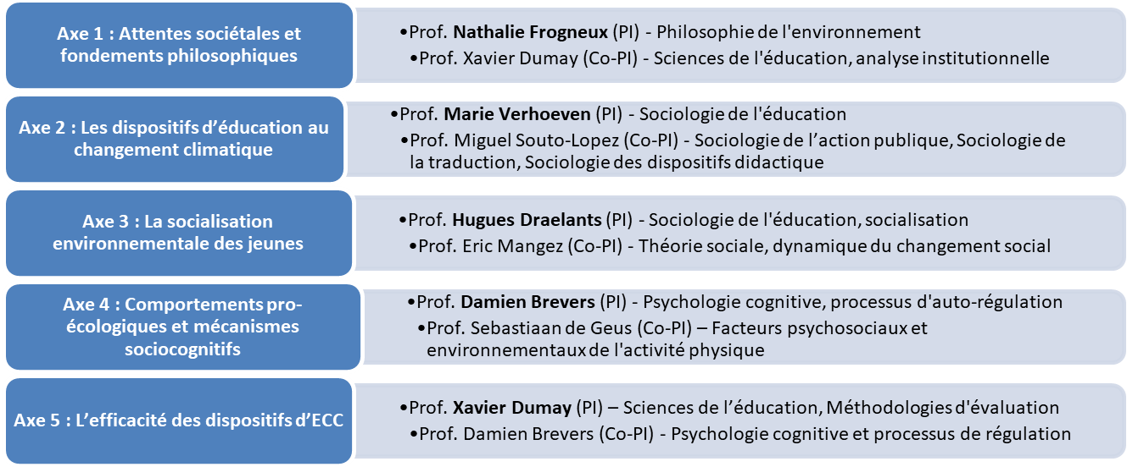

**Outline of axis 3 of the project “CLIMEDUC”**

***Environmental socialization of young people in a plurality of life spheres***

The third axis tests the hypothesis that Climate Change Education (CCE), far from taking place in a social vacuum, is constantly confronted with other socializing influences (family, peers, media, school, daily experiences, etc.) that can reinforce it or, conversely, nuance or even contradict it. Therefore, it is necessary to move beyond a school-centered vision of CCE to examine how young people's (16-20 years old) environmental attitudes and dispositions are formed at the intersection of these multiple spheres of socialization and through their everyday practices embedded in socio-technical systems. This axis analyzes the complex interplay between these different socializing influences (potentially consonant or dissonant) and CCE devices, and how they jointly impact the adoption of pro-ecological attitudes, dispositions, and behaviors, considering both constraints and potential levers for change within young people's lives.

**, Image**

**Job offer for a full-time 4-years PhD in the CLIMEDUC consortium on climate change education**

The CLIMEDUC consortiumis recruiting 5 PhD students for the project:

***“Climate Change Education Under Scrutiny: Towards a Theory of Institutional, Socio-Material and Cognitive Change through Education“***

The **CLIMEDUC consortium** is made up of a dynamic, multidisciplinary (philosophy, education, sociology, and cognitive psychology) and ambitious research team with recognized expertise and an international research network. A total of five doctoral theses will be initiated on **October 1, 2025,** within CLIMEDUC based on funding from UCLouvain's Concerted Research Actions (ARC), with the aim to develop a university center of excellence in the research field on climate change education.

The third PhD (PhD 3) will focus on ***“Climate Change Education and Environmental Socialization of Young People in a Plurality of Life Spheres”*** (axis 3 of the CLIMEDUC project; see project details on page 2).

**Offer :**

* Full-time, 4-year PhD position funded by UCLouvain;
* Dynamic, interdisciplinary environnement within CLIMEDUC ;
* Supervision by Prof. Hugues Draelants (Faculty of Economic, Social and Political Sciences and Communication - Sociology of Education, Socialization) and Prof. Eric Mangez (Faculty of Economic, Social and Political Sciences and Communication - Social Theory, Dynamics of Social Change);
* Research program leading to a PhD after 4 years and the possibility of completing the doctoral training program at UCLouvain;
* The opportunity to obtain the highest academic degree (Doctor of Political and Social Sciences) at UCLouvain, which ranks among the top 200 universities in the world.

**Your profile:**

* You hold a Master of Science (120) in sociology or social sciences, with a strong interest in at least one of the following areas: youth or family sociology, sociology of education and socialization processes, or environmental sociology;
* An additional degree or training in family science research and/or environmental sciences will be valued;
* You want to understand the challenges of the ecological crisis and the related educational debates, particularly how young people engage with these issues;
* You are ready to make a full-time commitment to scientific research for 4 years and are strongly motivated to obtain a PhD.
* You have experience with (or a strong interest in developing expertise in) qualitative research methods (e.g., biographical interviews, ethnographic observation, qualitative data analysis);
* You are fluent in French and have a good command (oral and written) of English.

**How do I apply?**

Please email the following documents to **Prof. Hugues Draelants** ([hugues.draelants@uclouvain.be](mailto:hugues.draelants@uclouvain.be)) and **Eric Mangez** ([eric.mangez@uclouvain.be](mailto:eric.mangez@uclouvain.be)) by **2025** **June 23:**

* An Application Letter;
* Your Curriculum Vitae, including a significant extract from your work, such as your master thesis dissertation (bound in 1 file of 10 MB maximum).

**Procedure and Timetable :**

* Selected candidates will be invited for an **interview on UCLouvain campus** in Louvain-la-Neuve, but online interviews are possible.
* Selected candidates will be notified by **2025 June 27** for interviews on **2025 July 3 and 4**.

**, Image**

**Overview of the project “CLIMEDUC”**

**Full title:**

Climate Change Education” Under Scrutiny: Towards a Theory of Institutional, Socio-Material and Cognitive Change through Education

**Main goal of the project:**

The CLIMEDUC project aims to contribute to delineate what can realistically be expected from education when it comes to address climate change, building on an empirical analysis of educational processes at different levels, their limitations and potentialities for generating change. By combining philosophy, education, sociology and cognitive psychology, CLIMEDUC aims to unravel the interplay between individual actions, social structures, and cognitive processes, to unravel the complex and interdependent mechanisms of change, and to develop a theory of institutional, socio-material, and cognitive change through education. The CLIMEDUC project is divided into 5 complementary and interrelated research axes, each of which corresponds to specific objectives and will lead to 5 doctoral theses.

**Project PI and co-PI:**

 

**Outline of axis 3 of the project “CLIMEDUC”**

***Environmental Socialization of Young People in a Plurality of Life Spheres***

The third axis tests the hypothesis that Climate Change Education (CCE), far from taking place in a social vacuum, is constantly confronted with other socializing influences (family, peers, media, school, daily experiences, etc.) that can reinforce it or, conversely, nuance or even contradict it. Therefore, it is necessary to move beyond a school-centered vision of CCE to examine how young people's (16-20 years old) environmental attitudes and dispositions are formed at the intersection of these multiple spheres of socialization and through their everyday practices embedded in socio-technical systems. This axis analyzes the complex interplay between these different socializing influences (potentially consonant or dissonant) and CCE devices, and how they jointly impact the adoption of pro-ecological attitudes, dispositions, and behaviors, considering both constraints and potential levers for change within young people's lives.